**Name: Amna Roll no: 60**

**“**Concepts of physics relevant to environmental science**”**

**The 4 Most Fundamental Physics Concepts:**

**1)Classical Mechanics (The Laws of Motion)**

Newton laid out and explained the three fundamental laws of classical mechanics:

1) Objects at rest will remain at rest, and objects in motion will remain in motion at the same velocity, unless the object is acted on by an external force.

2) Force equals mass times acceleration (F=*m*a)

3) When one object exerts a force on another object, the second object exerts an equal and opposite force on the first.

2) **Electromagnetism:**

Electromagnetism refers to the forces generated by the electrons that are found in certain types of matter throughout the universe. Some types of matter, such as the compounds found in magnets, have electrons that are configured in such a way as to exert force on other electrons that are in “charged particles.”

**3)Relativity**

General relativity was expanded in the early 1900s when Albert Einstein created special relativity. In his writings, Einstein theorized an “absolute speed limit” for light a speed which could not be exceeded regardless of relativity.

**4)Thermodynamics**

The study of thermodynamics revolves around the relationship between heat, energy, and mechanical work. Thermodynamics revolves around 4 laws (that for whatever odd reason are numbered zero through three). The laws emerge from a basic interpretation of heat as movement.

At an atomic level, what we perceive as “temperature” actually refers to atomic movement. On a hot day, for example, solar energy excites the atoms in the Earth’s atmosphere to vibrate rapidly.

**Application of physics in environmental science**

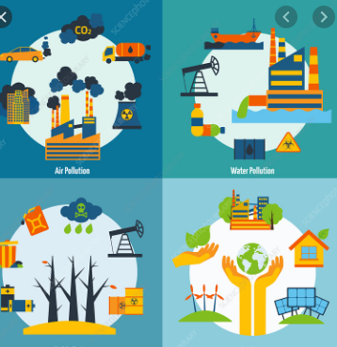Application of Physics concepts is quite an integral part of Environmental science. For example, we need mechanics for understanding the movements of tectonic plates below the surface of earth and even formation, weathering and erosion of rocks.

* Fluid mechanics is useful for studying air circulation in atmosphere and water movements in oceans, seas and other water bodies. Thermodynamics might be useful for studying global warming.
* Environmental physics, an option in the physics major, is the application of principles of physics to problems in the natural and man-made environment. It covers such things as the development of sensors and "green" materials, interaction of sunlight with airborne particulates, energy conservation, and disposal and storage of radioactive wastes. **Figure 1: physics related to Env. Science**
* Physics is the most basic natural science and considers physical systems ranging in size from nuclei, to atoms, to the cosmos. It is an extremely broad field, with many sub-fields.

**The role of physics in solving environmental problems air pollution**

Many of the environmental sciences involve modeling of the natural world, which required physics. For example, we may model a plume of pollution as it moves downwind, or the hydraulics of water in a river in order to estimate erosion.

Environmental science is an incredibly broad subject. Basic courses in ES require some Physics so as to understand energy conversions, generation of energy, alternative energy sources. Calculating the efficiency of a system and even understanding important subjects like the greenhouse effect.

However some environmental scientists focus on fields which do not require any in depth knowledge of Physics.